**الاسم: عمر رأفت حمدي عبدالفتاح**

**السكشن :24**

**8:BN**

**رقم الجلوس :530**

**Application brief :**

Big data is a field that handles methods for systematically analyzing or extracting information or dealing with very large or complex data sets that cannot be handled by traditional data-processing application programs. Big data was originally associated with three main concepts: size, diversity, and speed. When we deal with big data, we may not take a sample but observe and track what happens. Therefore, big data often includes data in volumes that exceeds the ability of traditional programs to process at an acceptable time and value.

* Big Data Applications:

Big data has found many applications in various fields today. The major fields where big data is being used are as follows.

* Government
* Social Media Analytics
* Technology
* Fraud detection
* Call Center Analytics
* Banking
* Agriculture
* Marketing
* Smart Phones

**Screen shots :**

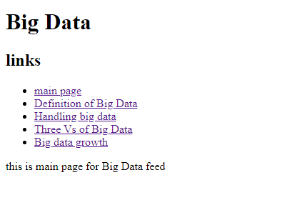

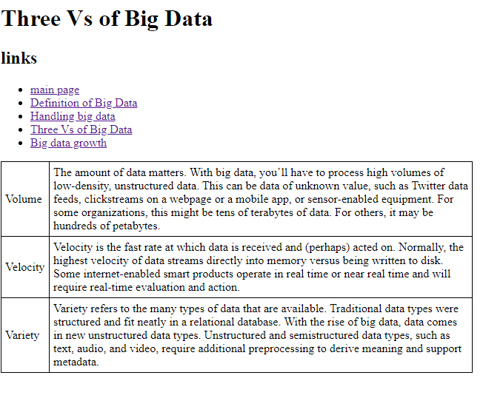

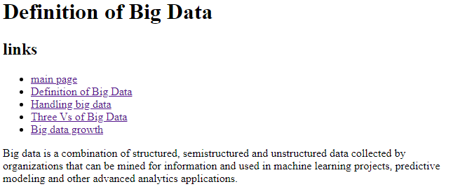

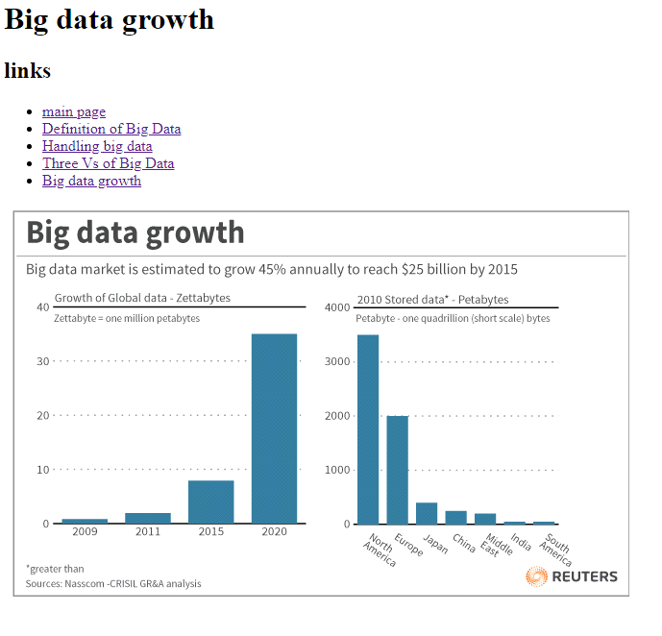

Screen code:

